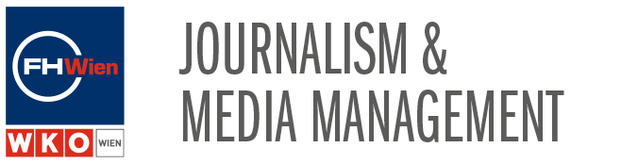

„EU ON AIR“ in Vienna
Sustainable Development is an important aim when it comes up to a free, independent and pluralistic media in relation to the normative educational discourse. In correcting ecological imbalances and responding appropriately to environmental challenges it is necessary to focus on various city-projects. The Viennese city government is focussing on diverse concepts for creating a sustainable city.

Generally Vienna is known as a traditional based town when it comes up to imperial architecture, the world of music or famous art galleries. But the town is very diverse, modern with plenty of community projects, set, to improve the urban development. Specially since 1999 the Viennese city government is realizing a very ambitioned climate protection programme which has been leading into the so called „Smart City Vienna“ - the city governments title for taking also climate change initiatives into scale in various sectors.

The studyprogramme Journalism & Media Management at the University of Applied Sciences for Management and Communication – the FHWien - is focussing on current journalistic approaches which are able to get researched, explained & published, always with a critical approach where journalistic quality is taken into consideration.

Therefore this years radioproject „EU On Air“, taking place in Austrias capital Vienna, will focus on sustainable development projects taking place in the city. From moving innovative urban initiatives to future orientated scientific developments – there is a lot to investigate. Always with a critical eye on which targets are already implemented in Austrias policy or which requirements still has to reach certain standards against climate change in terms of a sustainable development.

Vienna – Projects/Topics/Subthemes:

- Sustainable Energies: (photovoltaic/solarenergy for electricity or heating, waterpower, burn garbage, safe energy on buildings or household equipment, windenergy)

- Conservation areas: (europe conservation areas „Natura 2000“ national parks, green spaces, biodiversity projects, diversity of species, preservation of open spaces)

- Innovative Mobility (public transport System, public spaces, mobility concepts in living areas, walking & bicycle & cartogo, E-Scooter etc.)

- Cool Vienna (to cool down the city): (more Viennese Parks & preserveration areas & more „cool“ new places with water hoses, water spray showers, urban heat islands, drinking wells etc.)

These four general Subthemes have many detailled subangles. So to choose/focus on one of these - in terms of „Pars pro toto“ (one detail for the whole, the more defined the better) - it should be a wide range to choose and look into relevant circumstances.

Projects for the intercultural student groups in Vienna:

- After some speakers … (they will be organised to speak for subthemes/initatives/critic)
- A topic/subtheme/subangle will be chosen
- Research & collect information
- Look for and visit some urban relevant scenes in Vienna!
- and do the recording interviews there!!
- create a feature of 7 minutes
- production
- presentation of one hour radio show

Final broadcast On Air of Radio NJOY 91.3:

- collect all the features of the group
- choose a presenter for the whole team
- and prepare one hour radio show with music and broadcast it on Radio NJOY 91.3 – on our educational radio!!
Students/Groups: 32 Students – 5 Groups á 6-7 students
- Esko (4 students)
- Manuela (4 students)
- Tiko (5 students)
- Wilfried (7 students)
- Karina (7 students)
- Sara (4 students)
Lecturers: Esko, Manuela, Tiko, Wilfried, Sara, Karina
Jury: Nadia, Tiko, Nezih, Karina, Elisabeth Stratka (ORF-Radio Ö1)

Format Pilots for the student groups in your hometown country:

- To give an inside into your Country/City perspectives
- Are there initiatives against climate change in terms of a sustainable development in your city and do they fulfill the expectations?
- Critical approach towards some city projects!!
- Create a Feature of 15 to 20 minutes
- Short Video-Presentation of the different teams
- Deadline for uploading Features & Videos: Fr 22nd of May
- And load it up to the www.europeonair.com – Website.
EU ON AIR – DATE:
First week in June (2.06. to 06.06.) – Mo 01.06. is a bank holliday.

