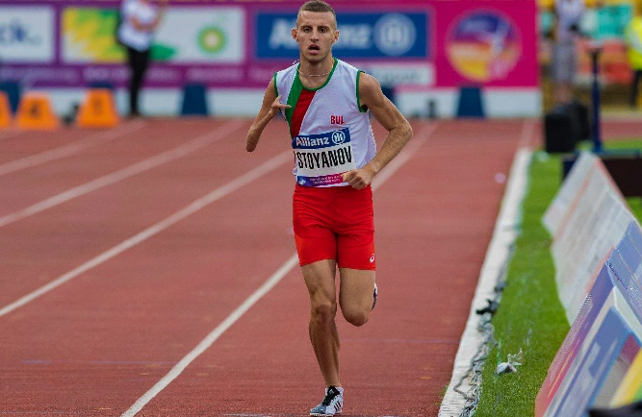

Name: Hristiyan Nikolaev Stoyanov

Date of birth: 20/08/1998

From Gabrovo, Bulgaria

Phone number: +359 878 90 56 00

Facebook: <https://www.facebook.com/hristiqn.stoqnov.925>

Instagram:

[https:/www.instagram.com/hriszstoyanov/](https://www.instagram.com/hriszstoyanov/)

WHO AM I?

I am Bulgarian athlete, Paralympian and runner.

Now I am 20 years old.

I compete in 800m., 1500m., 5000m. and cross country.

I run in Paralympic races for disabled and even in races for normal people.

My coach is Evgeni Ignatov. He is national record holder of 1500, 2000, 3000, 5000 and 10 000m. Now he is 59 years old and making me better runner.

Outside athletics I study Public Relations in Sofia University “St. Kliment Ohridski”.

I want is to be the best Paralympic middle distance runner in the world.

**My aims in athletics for 2019**

World Para Athletics Championships Dubai 2019 – top 3 in 1500m.

Bulgarian National Championships 2019 – top 3 in 800m. and 1500m.

World Para Athletics Grand Prix Tunisia 2019 – 1st place in 1500m.

World Para Athletics Grand Prix Berlin 2019 – 1st place in 1500m.

**The Biggest Aim – Paralympic Games in Tokyo 2020 – top 3 in 1500m.**

**My aims for 2019 in numbers**

400m. – 51,00

800m. – 1,52,00

1500m. – 3,51,00

5000m. – 14,30,00

10 000m. – 31,00,00

**Personal bests**

400m. – 52,69

800m. – 1,54,31

1500m. – 3,55,98

3000m. – 8,31,24

5000m. – 15,06,62

RESULTS:

**For disabled people in seniors**

European Para Athletics Championships Berlin 2018 – 1st place – 1500m.

World Para Athletics Grand Prix Berlin 2018 – 1st place – 1500m.

World Para Athletics Championships London 2017 – 3rd place - 1500m.

Paralympic Games Rio 2016 – 7th place – 1500m.

**For disabled people in under 23 years old**

6 times champion in IWAS World Games: 1500m. – 2014, 2015, 2016, 2017; 800m. – 2015, 2016

**Normal Races – all in seniors**

Bulgarian National Championships Indoor 2019 – 2nd place – 800m. with PB 1,54,31 and 3rd place – 1500m.

Balkan Athletics Championships Outdoor 2018 – 9th place – 1500m. and 6th place 3000m.

Balkan Cross Country Championship Under 23 years 2018 – 10th place – 8000m.

Bulgarian Cross Country National Championship Under 23 years 2018 – 2nd place – 8000m.

Bulgarian National Championships Outdoor 2018 – 2nd place in 1500m. and 3rd place 5000m.

**Normal Races 2017 – all in under 20 years old**

Balkan Athletics Championships Outdoor 2017 – 5 000m. – 3rd place

Bulgarian National Championships Outdoor 2017 – 1500m. – 2nd place and 5 000m. – 1st place

Bulgarian National Championships Indoor 2017 – 1500m. and 3 000m. – 1st places

Bulgarian Cross Country National Championship – 6 000m. – 2nd place