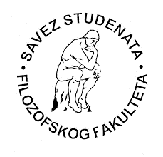
University of Novi Sad
Faculty of Philosophy
25 March 2019

Faculty of Philosophy, University of Novi Sad and Students’ Alliance of the Faculty of Philosophy

Would like to inform you that the number of participants in the International Students’ Assembly Filozofijada 2019 in Sunny Beach, Bulgaria (duration period: 03.05. – 08.05.2019) should be as it follows:

- Futsal – 10 players
- Basketball (men) – 10 players
- Volleyball (men) – 10 players
- Volleyball (women) – 10 players
- Chess – 3 players
- Table tennis – 3 players
- Debate – 3 participants
- Quiz – 3 participants

Dalibor Mirić,
President of the Students’ Alliance of
the Faculty of Philosophy

