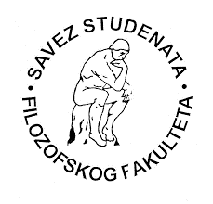
University of Novi Sad
Faculty of Philosophy
25 March 2019

Faculty of Philosophy, University of Novi Sad and Students’ Alliance of the Faculty of Philosophy

Would like to inform you about all the other faculties that have confirmed participation in the International Students’ Assembly Filozofijada 2019 in Sunny Beach, Bulgaria (duration period: 03.05. – 08.05.2019).

- Faculty of Philosophy – Skopje
- Faculty of Philology – Kosovska Mitrovica
- Faculty of Philosophy – Niš
- Faculty of Philosophy – Belgrade
- Faculty of Philology – Belgrade
- Faculty of Philosophy – Novi Sad
- Faculty of Philosophy – Mostar
- Faculty of Philology – Banja Luka
- Faculty of Philosophy – Sarajevo
- Faculty of Philosophy – Sofia
- Faculty of Philology and Art – Kragujevac
- Faculty of Philosophy – Nikšić
- Faculty of Philology – Nikšić
- Faculty of Philosophy – Rijeka
- Faculty of Philosophy – Split
- Faculty of Philosophy – Osijek
- Faculty of Philosophy – Zagreb
- Faulty of Philosophy – Novi Pazar

Dalibor Mirić,
President of the Students’ Alliance of
the Faculty of Philosophy

